Category-Informative
Company-TechNewKB
Keyword-{convert, migrate, export} Gmail to PST

Keywords:
export gmail to pst file, how to import gmail to outlook, how to export gmail emails, extract emails from gmail, export google mail to pst, convert gmail to pst, switch to outlook from gmail, how to export gmail to pst, gmail imap settings, Gmail to Outlook converter, Gmail to PST converter tool

Extra Keywords:
export gmail calendar to outlook, export contacts from gmail to outlook, gmail pst import tool, transfer contacts from gmail to outlook, how to sync gmail contacts with outlook, how to convert gmail to outlook, how to import Gmail to PST, Convert Gmail to Outlook

How to Convert Gmail to PST

Nowadays, many users opt for a desktop-based email application to access their emails without a browser. This way, they can access their emails even without an Internet connection. Therefore, users choose to migrate from Gmail which is a web-based email client, to desktop-based Outlook. It is important for users to export their Gmail data to Outlook (PST) for a smooth transition. In this blog, we will discuss how to export Gmail to PST. For full migration, users have to export emails and contacts separately.
It is important to note that both Gmail and Outlook have good features. But, some users prefer Outlook because multiple email accounts can be accessed from Outlook. With offline use and quick navigation, Outlook is a reliable application even in offline mode. In the following sections, we will elaborate the need and various methods of

Need to Convert Gmail to Outlook
When users want a desktop-based email client, MS Outlook is their first choice. It is a reliable application with different features as compared to Google. Users can configure multiple email addresses in Outlook and access them in a clean manner. Outlook has excellent sorting features and good data security. Therefore, users are increasingly migrating to Outlook. Users also want to import their important Gmail emails, and contacts, etc. to Outlook. This is important because it is difficult for users if they need an old email. It can be better understood with these user queries focussing on why users need to switch to Outlook from Gmail:
- “I recently got a new job where they use MS Outlook for official purposes. I regularly need access to my old Gmail emails. But it will be very difficult to open Gmail every time I need an email or save an old attachment. Does someone know how to import Gmail to Outlook?”
- “In my office complex, there is a severe internet connectivity issue. I am unable to quickly access my Gmail emails. A friend recommended Outlook for excellent desktop use. Now, I need to extract emails from Gmail and open them in Outlook. Is there a way to export Gmail to PST file?”

Methods to Convert Gmail to PST
As seen above, there is a growing need to export Google mail to PST.

Solution 1- In the manual method, the users can configure Outlook with their Gmail ID. New users can create a fresh Outlook profile. Users who have already configured their Outlook with an email address can add another account. Once configured, Outlook will synchronize and display all Gmail emails, Calendar, Contacts, and Notes in Outlook as well. Now, users can export this data to PST using the Import/Export feature of Outlook. This method is applicable to all versions of Outlook.

The manual steps for this conversion are as follows:
- Open Gmail account that you want to export to Thunderbird.
- Click on Settings >>Settings.
- Select the tab ‘Forwarding and POP/IMAP’. In the IMAP Access section, select ‘Enable IMAP’. Click on ‘Save Changes’. And exit.
Note: Users need to enable the Gmail IMAP settings, otherwise Outlook will report an error. It would not be able to synchronize the emails in the desktop application.
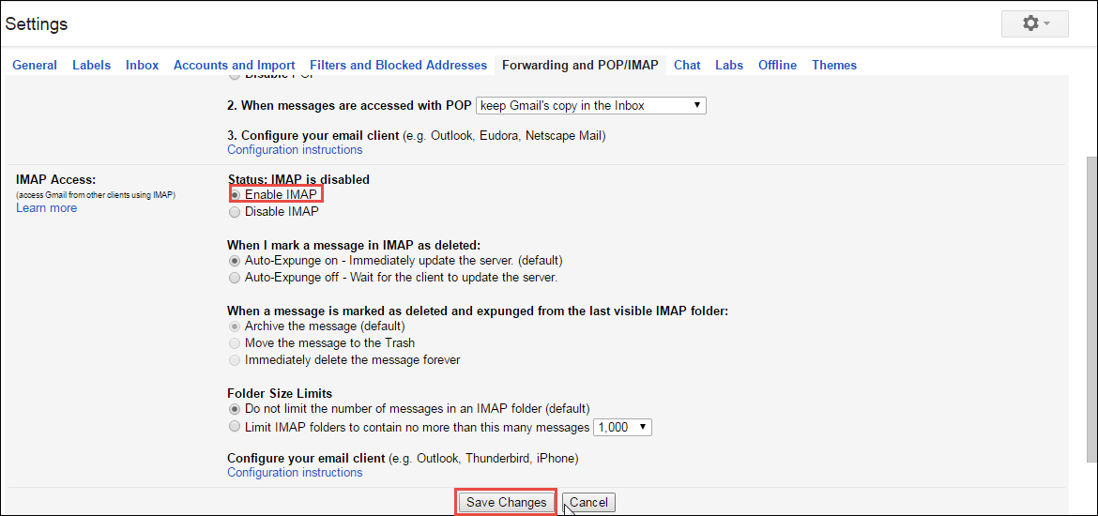

- Open MS Outlook and create a new profile.
- Enter your name, email address and click Next.
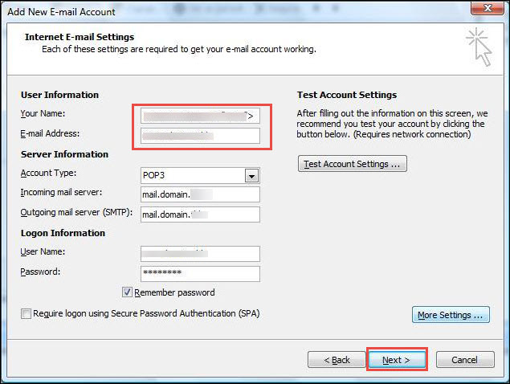

- Once the authentication is complete, Outlook displays the emails, contacts, calendars, etc. for that email address.
- Click File<<Import/Export.

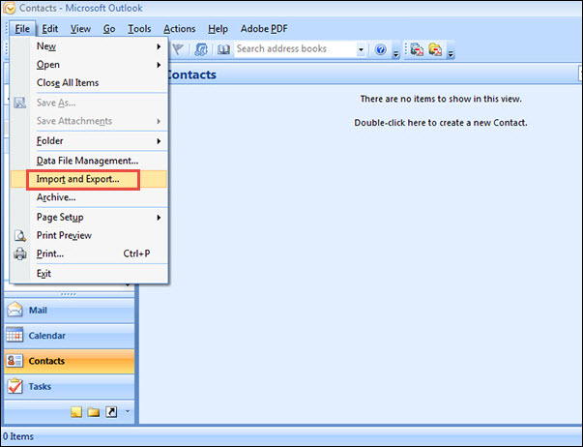
- In the new window, choose ‘Export to a file’.
- Choose Outlook Data File (.pst).
- Select which Outlook folder to export and choose the location for the .pst file.
- Click OK to Finish.
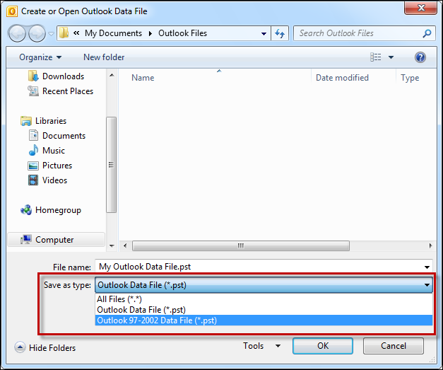

This way, a new PST file with all Gmail data is saved on the hard disk at the location specified by the user. This PST(Personal Storage File) is compatible with Outlook and can be accessed at any time.

Tip: The resultant PST also works as a backup file for all Gmail data.

Solution -2: Since the manual method is time-consuming, users can opt for a third-party Gmail to Outlook converter. It is a secure and reliable automated software-based alternative.

Conclusion
Since a lot of users prefer to use a desktop-based email client such as Outlook. Moreover, users can set up more than one email address in Outlook and access them at the same time. Since this feature is not possible in a web-based email client like Gmail. They migrate from Gmail and need to import their emails, contacts, and calendar, etc. for a smooth transition. It is important for users to know how to export Gmail emails so that they can be opened in another application such as MS Outlook. Therefore, in this blog, we discussed the methods of how to convert Gmail to PST. The manual method consists of configuring Outlook with the Gmail address and exporting this Outlook data to a PST file. A PST file is automatically generated when Outlook is configured with a new email ID. But, users can specifically export Outlook data to a PST file at the desired location as well. As an alternative, users can choose a third-party Gmail to PST converter tool.

